 Project Report Template

1. **INTRODUCTION** 
   1. Overview

A Personal Money Maintenance app.

* 1. Purpose

To keep track of money being used and set a limit **2 Problem Definition & Design Thinking**

2.1 Empathy Map

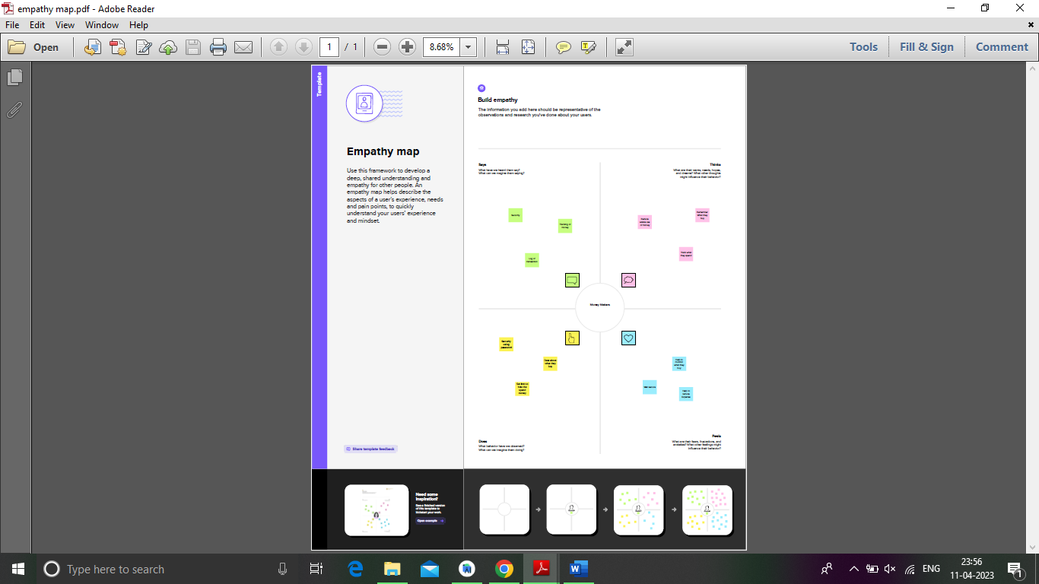

2.2 Ideation & Brainstorming Map

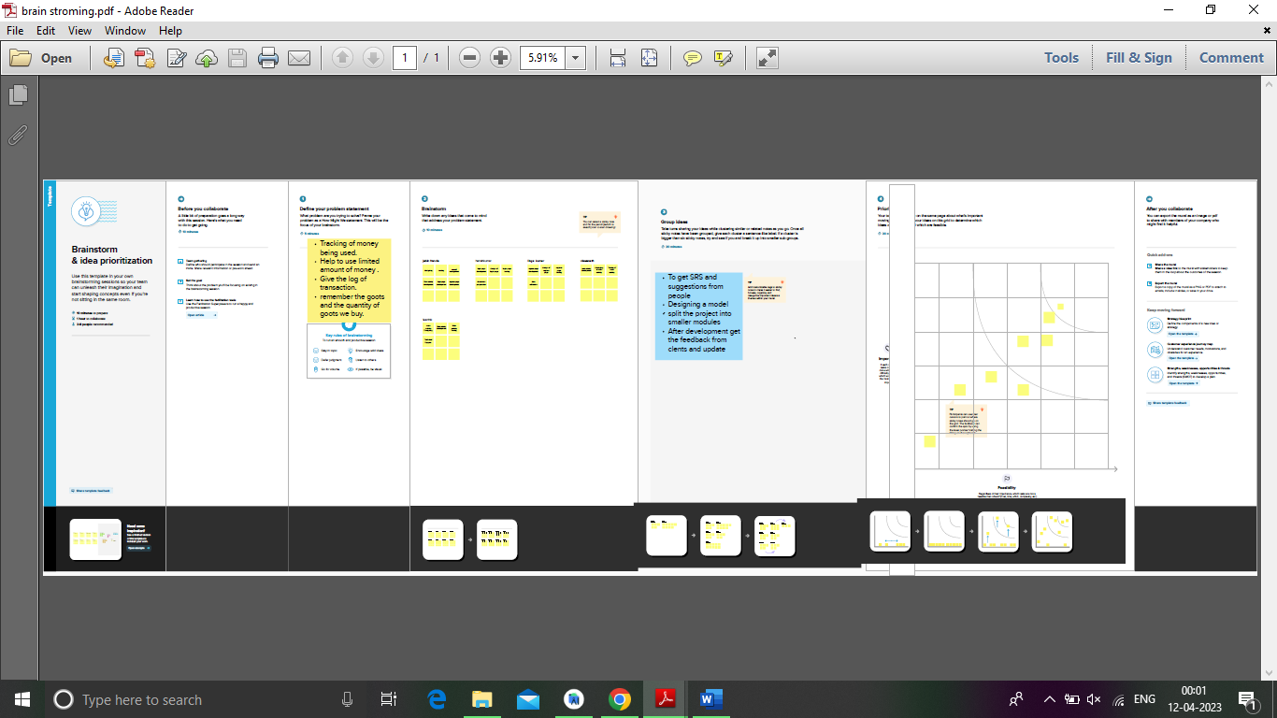

1. **RESULT**

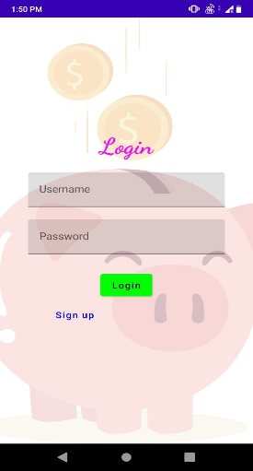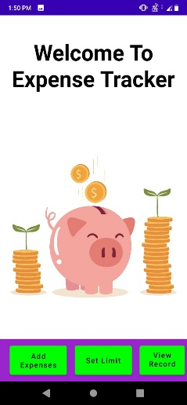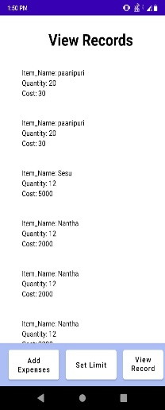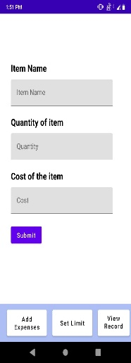

A Best app to Maintain your financial expenses.

1. **ADVANTAGES & DISADVANTAGES**

*Easy to use

*Reduce Money We spent

*keep track of your money

1. **APPLICATIONS**

* Houses
* Office
* Personal app
* college

1. **CONCLUSION**

It work extremely well and need some minor problems.

1. **FUTURE SCOPE**

Enhancements and update must done in future.

1. **APPENDIX**

<https://github.com/jebinfrancis10k/Money-Maters-A-Personal->Finance-Management-App